JEEVAN RAKSHA MYSQL project
- Made by BHARATH KUMAR NEERUKONDA

- ER diagram
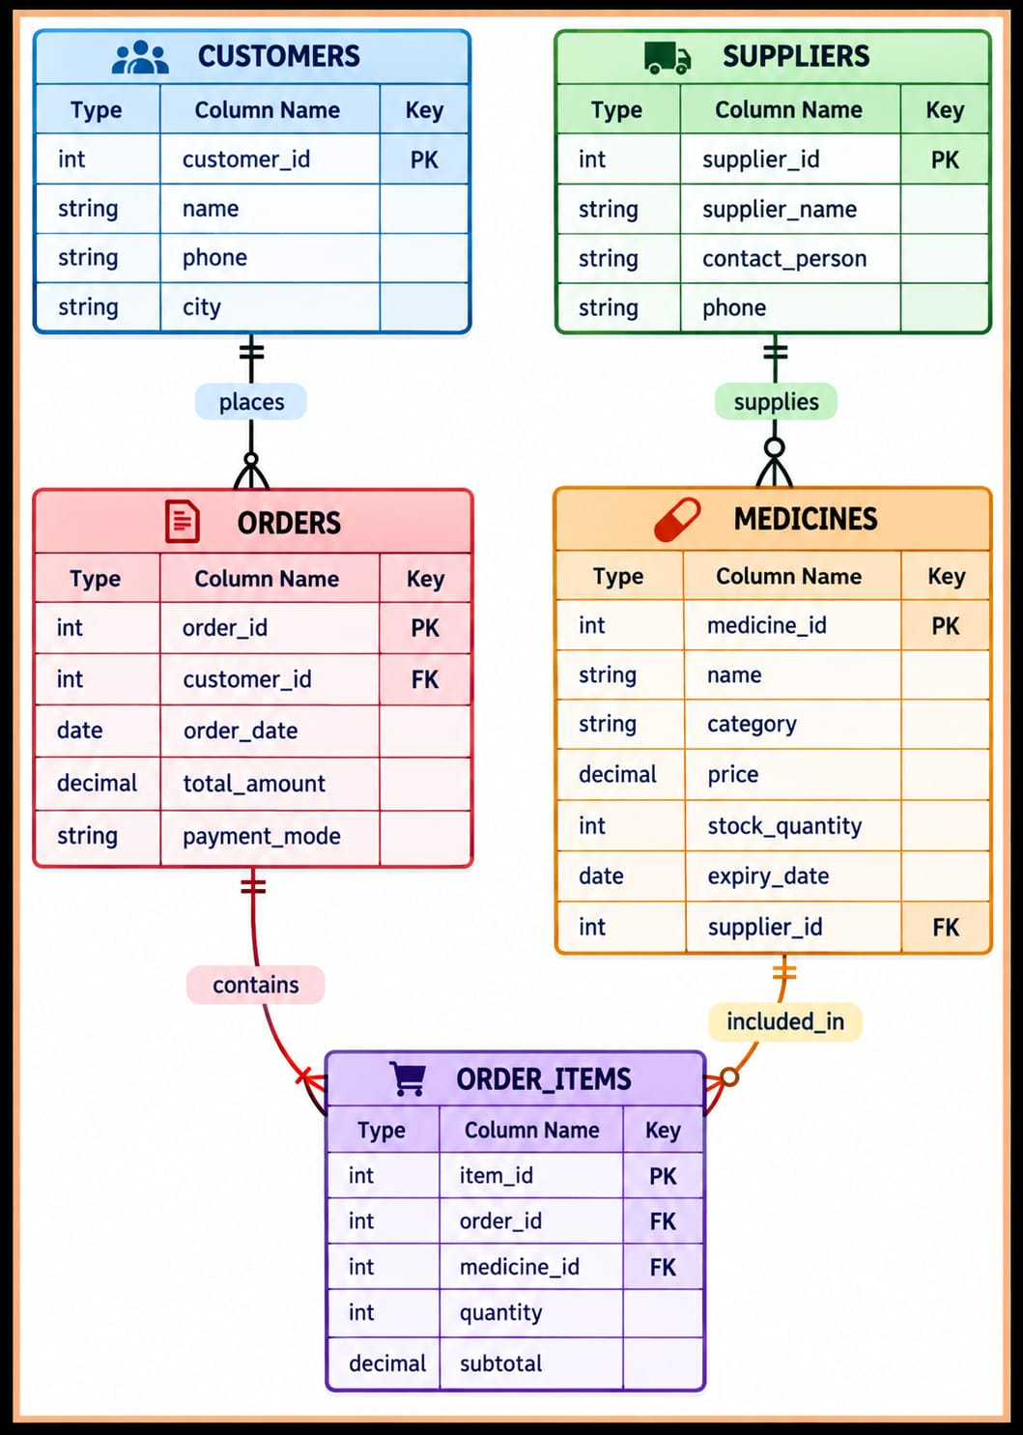

- Initial Setup of database, tables, sample data

- Setup :

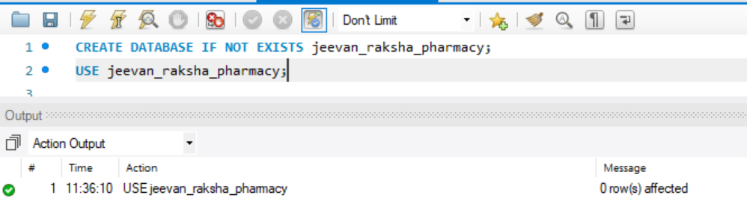

- Tables :

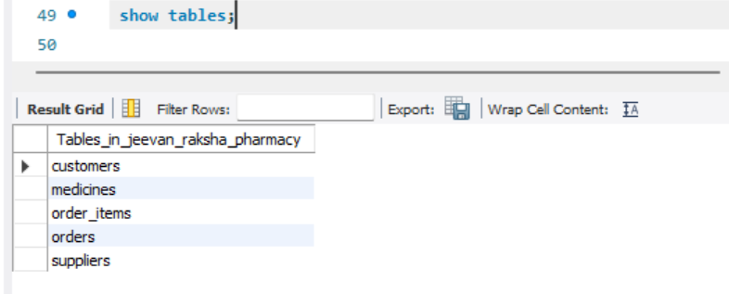

- Sample Data :

I. customers
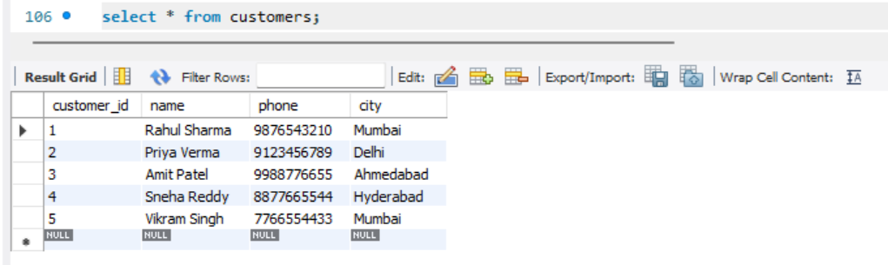

II. Suppliers
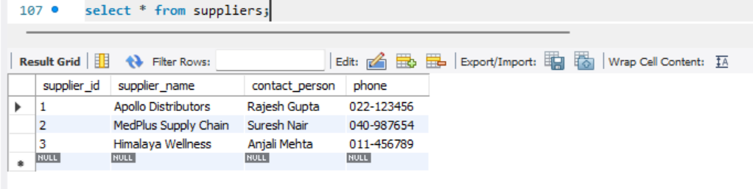

III. Medicines
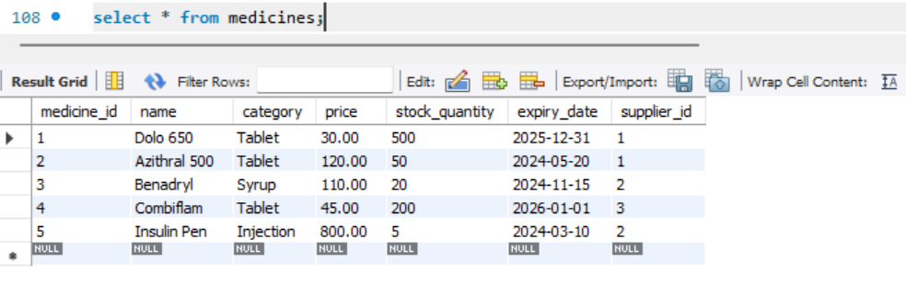

IV. Orders
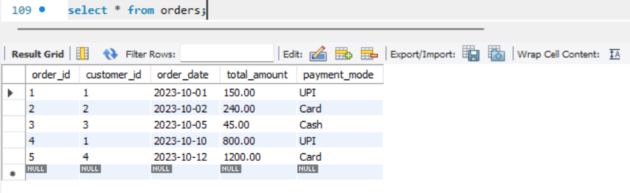

V. Order items
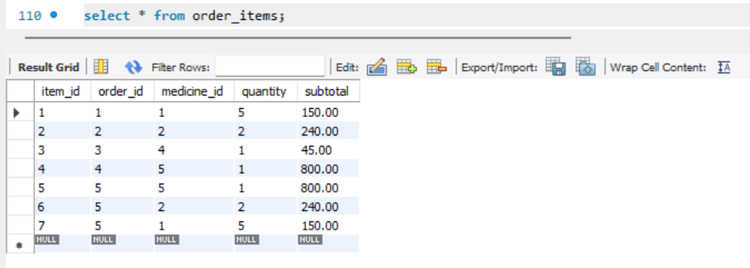

Simple Queries :

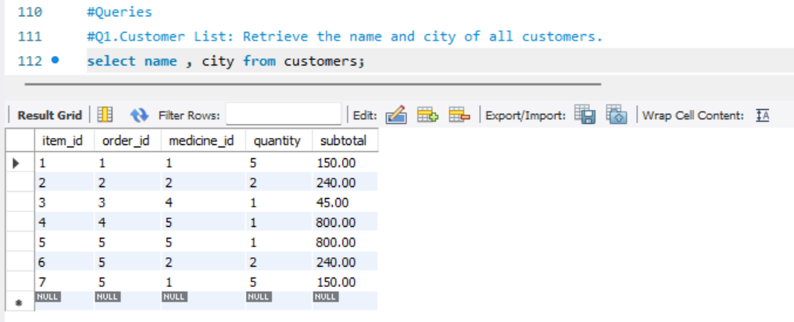

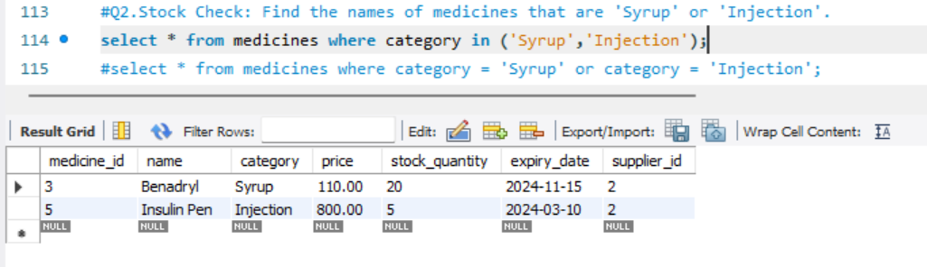

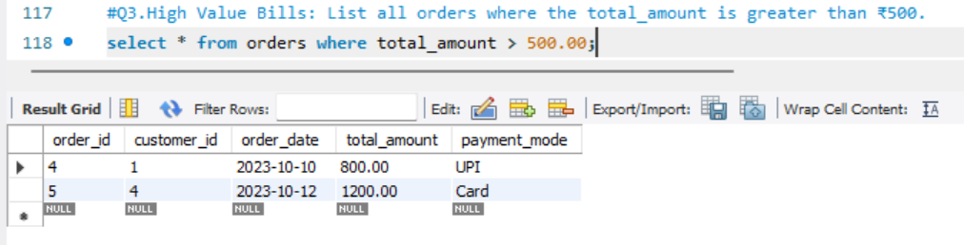
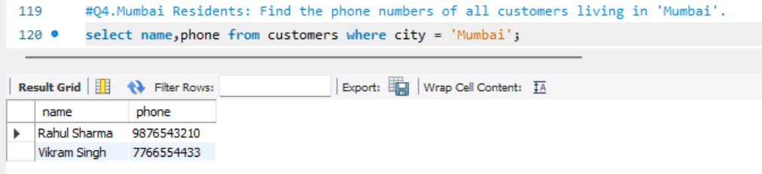

Aggregate & Join Queries:

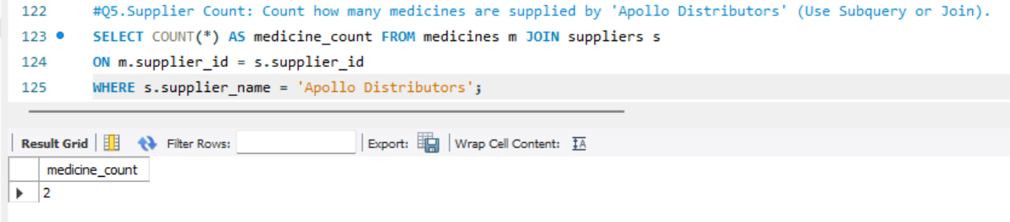

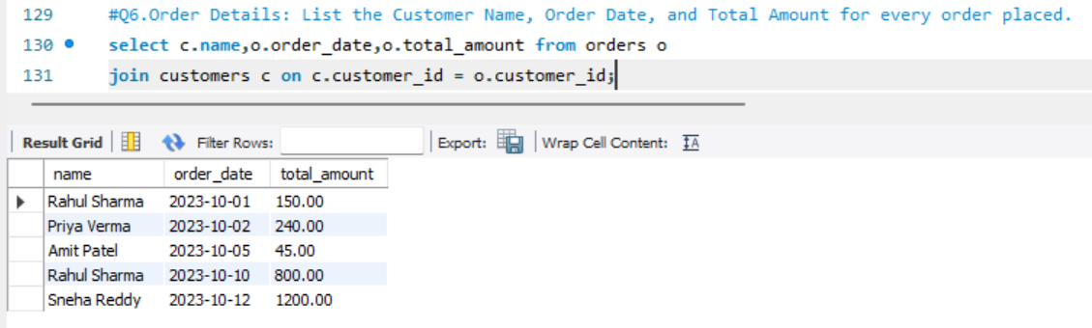

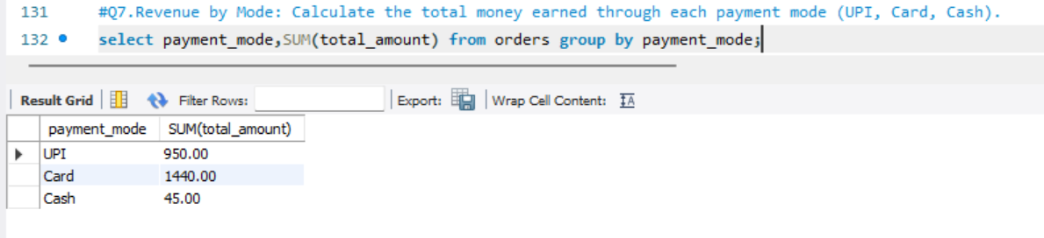

Complex Queries:

